Finally, after developing all of your code, you must test and deploy the dashboard to make sure that all of your components work. To complete this step, run your IPYNB file. You must either take screenshots or create a screencast of your dashboard and widget functionality. Each of your screenshots or your screencast should contain the Grazioso Salvare logo and your unique identifier. Your screenshots or screencast must show the following:
- The starting state of your dashboard, which should include your widgets for the interactive options to filter data (such as radio items or drop-downs), the interactive data table, and the charts

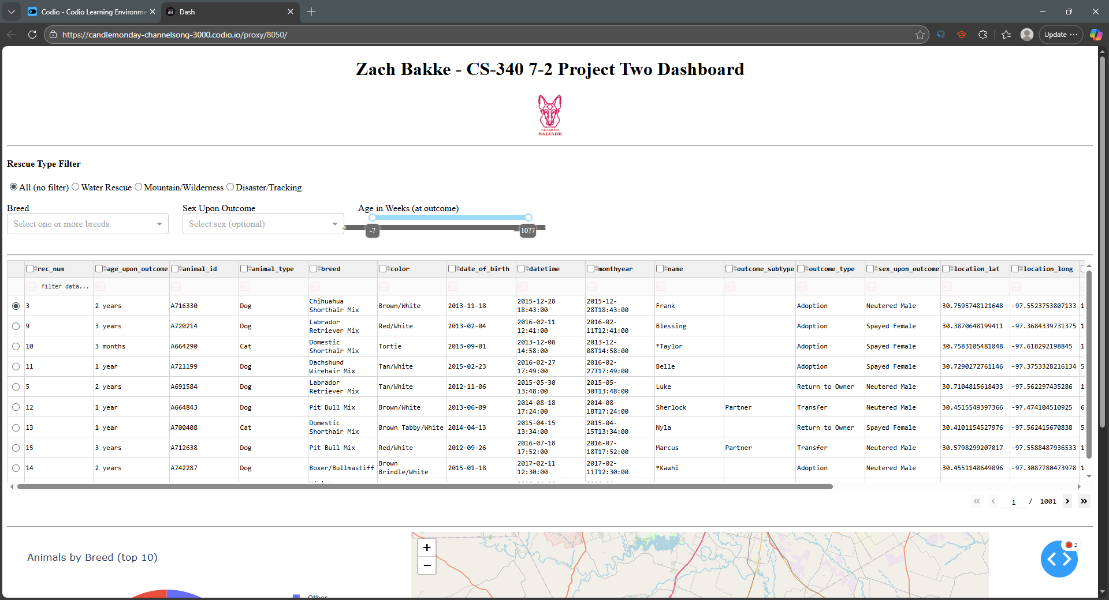
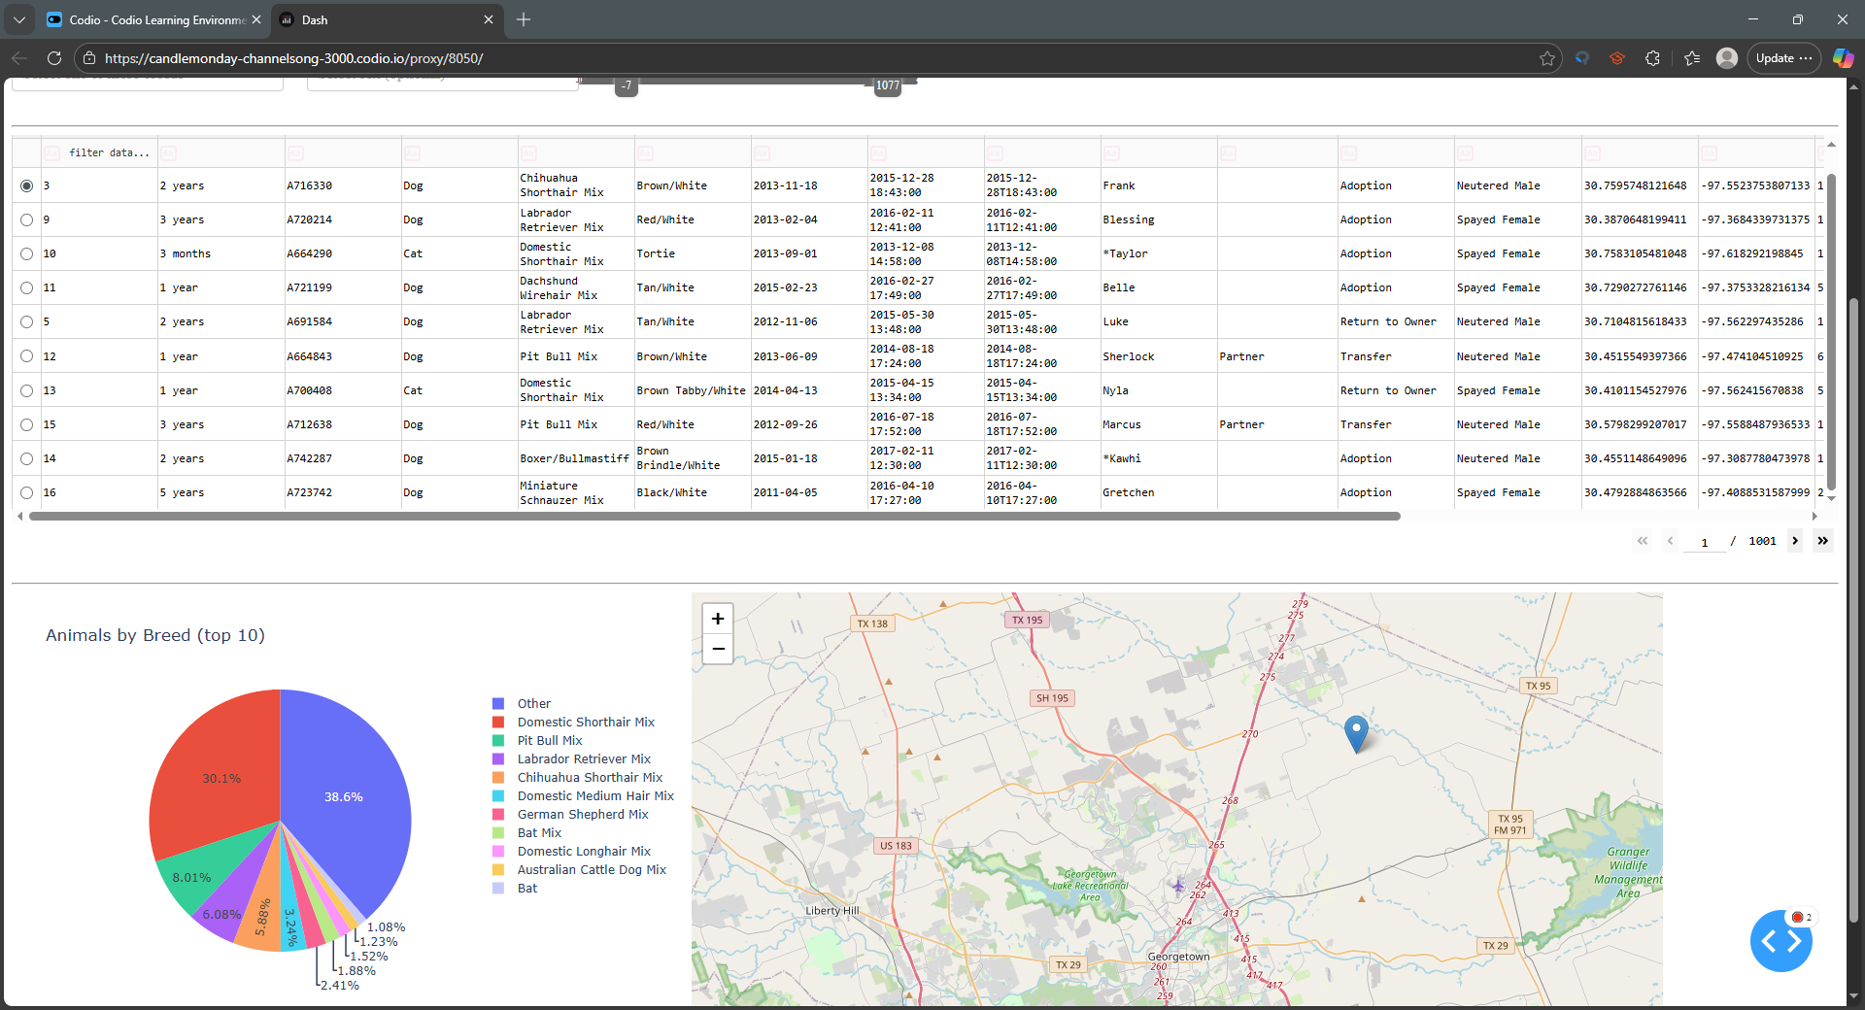
- Executions of your dashboard, showing the widgets after each of the following data filters has been applied (four screenshots total):
  - Water Rescue
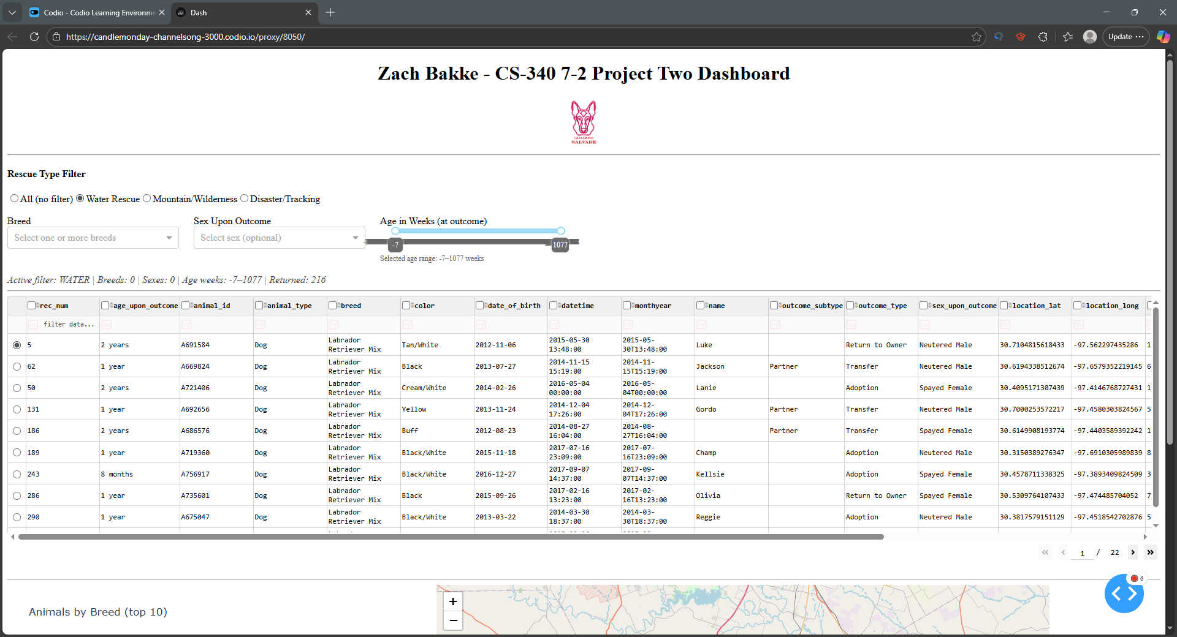
  - Mountain or Wilderness Rescue
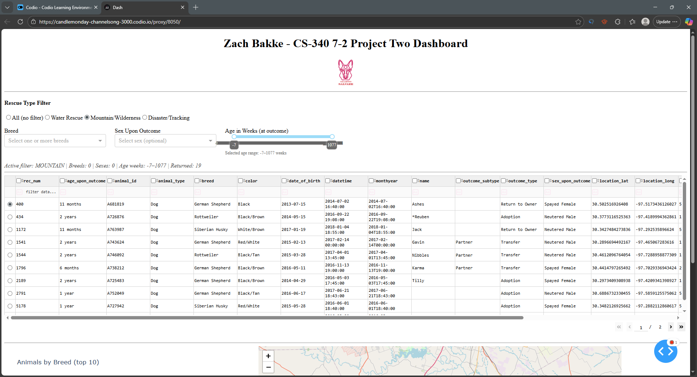
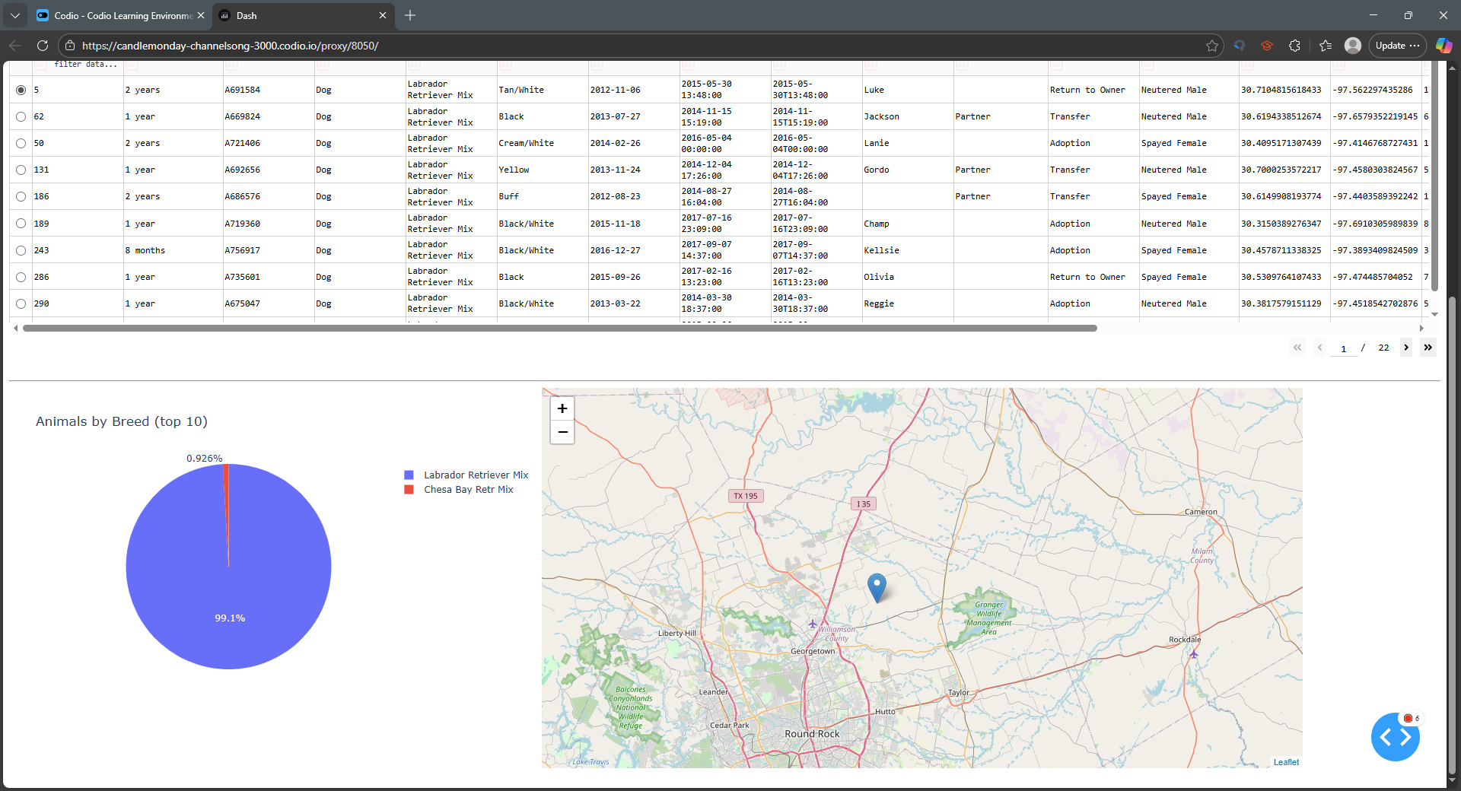
  - Disaster or Individual Tracking
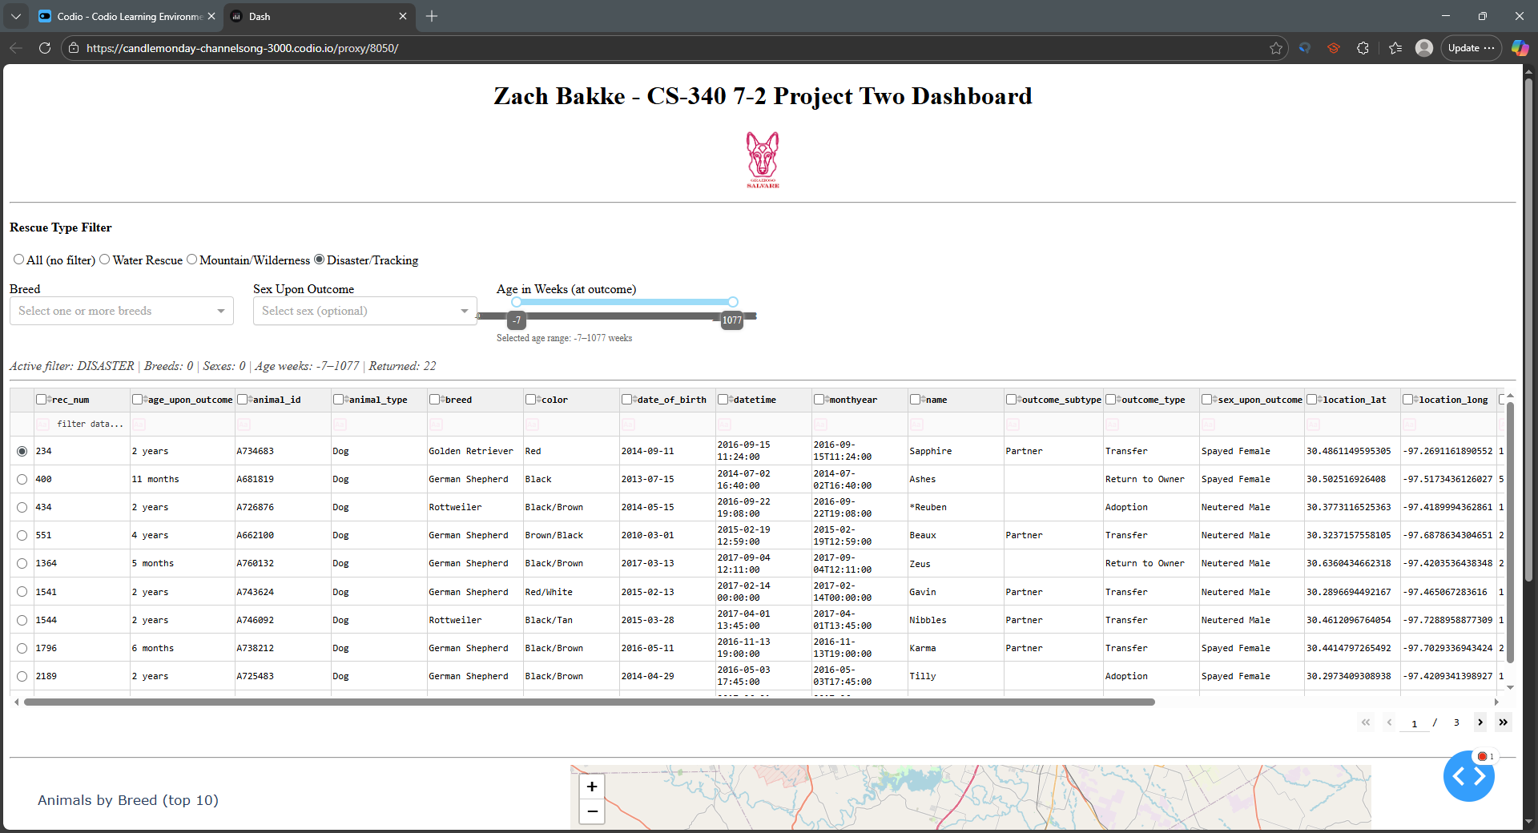
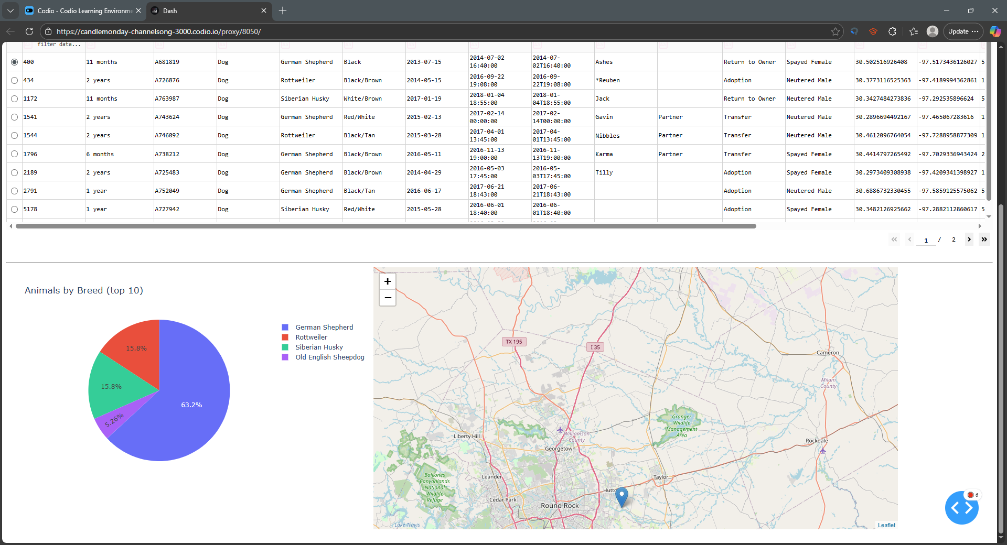
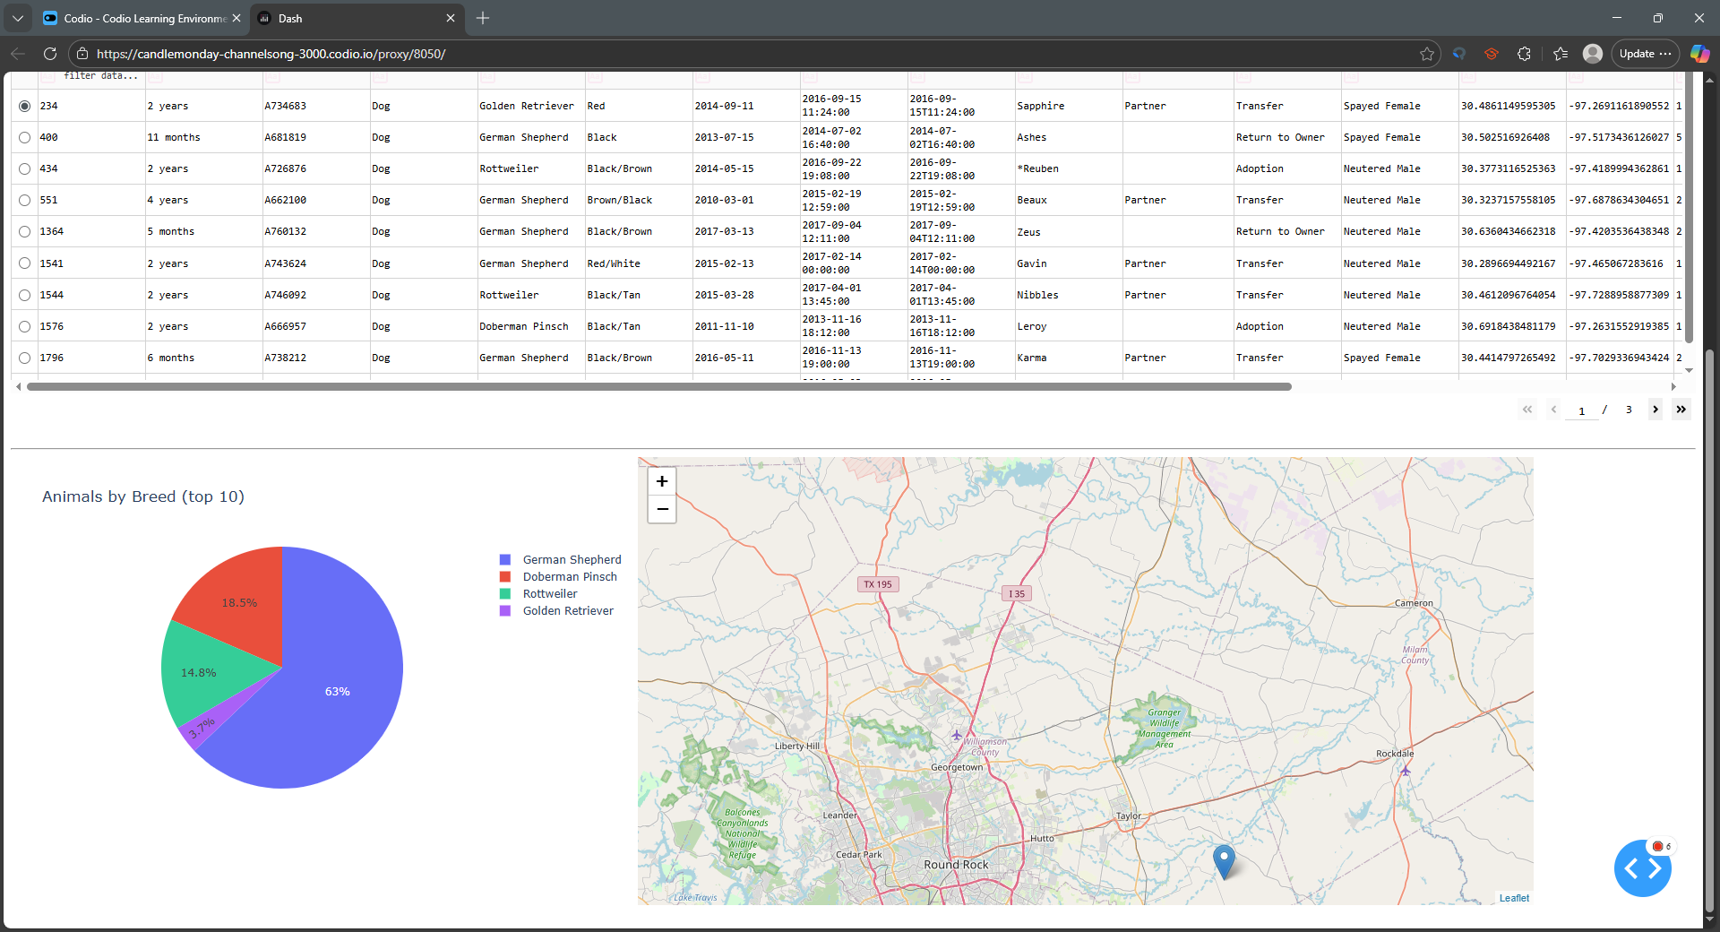
  - Reset (returns all widgets to their original, unfiltered state)
